Strategic Success Measures
October 2020

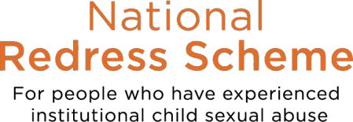
Foreword
In April 2020, the Ministers’ Redress Scheme Governance Board commissioned the establishment of a set of success measures for the National Redress Scheme for Institutional Child Sexual Abuse (the Scheme). The success measures were developed in consultation with all state and territory governments, a sample of redress support services and advocacy groups, and are now reflected in the Intergovernmental Agreement on the National Redress Scheme for Institutional Child Sexual Abuse.

The measures focus on three priority areas within the Scheme, Survivor Experience, Health of the Scheme and Equity of Access. The first release of the success measures represents the initial step to measuring the overall performance of the Scheme.

The Scheme is committed to a continual improvement process, this includes aiming to ensure that at least 80 per cent of applications that name institutions that participate in the Scheme have a decision communicated to the applicant within six months of being received by the Scheme. Furthermore, the Scheme will continue working closely with all state and territory governments to ensure institutions named in applications for redress join the Scheme.

While the success measures will provide greater transparency and accountability about how the Scheme is operating, it is important to acknowledge the priorities that have influenced results published in this first report, particularly the Scheme’s focus to process applications received prior to 30 June 2020 and the impacts of the COVID-19 pandemic.

The Scheme continues to improve and the success measures are important in tracking improvement and ensuring accountability. The reported data that follows represents an improvement in the Scheme’s second year of operation compared to the first year. More information on the Scheme’s improvement can be found in the Department of Social Services’ Annual Report.

The Minister for Families and Social Services remains committed to making every effort to improve the experience for survivors and expects this to be reflected in future reporting on the Scheme success measures. This includes actively working with named institutions in joining the Scheme, using financial levers for those who refuse to join the Scheme, and ensuring support services are able to support applicants throughout the process.

Statement of preparation
The Department of Social Services (the department) presents the National Redress Scheme Strategic Success Measures, which covers
the period 01 July 2019 to 30 June 2020. This report uses data up to 30 September 2020.

Source data: Services Australia for application data for the period ending 30 June 2020.
2

Key operating data:
In the second 12 months to 30 June 2020:
- a further 3,127 people applied for redress through the Scheme. The total number of applications received by the Scheme at 30 June 2020 increased by 74 per cent from the 4,200 applications received
as at 30 June 2019
- 3,059 people were assessed as eligible for redress
- 136 applications were assessed as ineligible
- 2,568 people accepted an offer of redress
- 10 people declined offers of redress
- of the applications assessed as eligible for redress, 929 institutions were found to have been responsible
across the individual cases of abuse
- 2,537 applications were finalised, including 2,504 redress payments were made ranging from less than
$10,000 to 150,000, with an average payment of $81,876
- the total value of redress monetary payments was $205,016,984
- 1,736 people requested counselling and psychological care as part of their redress outcomes
- 1,345 people requested a direct personal response from an institution
- 78.7 per cent of applications name more than one institutions in their application and 33.7 per cent of
applications name four or more institutions.

Substantial improvements in application processing have been made. From 1 July 2018 to 30 June 2019, the Scheme finalised (including a redress payment being made) a total of 239 applications, giving an average of 20 per month over the period. By comparison, from 1 July 2019 to 30 June 2020, the Scheme finalised a total of 2,537 applications, giving an average of 211 per month over the period.

3

1a. APPLICATION TIMELINESS
The data is an improvement on the figures from the Schemes first year of operation where 11% of outcomes were advised within 6 months of receipt, 19% within 9 months of receipt and 23% within 12 months of receipt.
Application progressing times have benefited from greater resourcing provided by the Commonwealth Government for more Independent Decision Makers, however many applications can still not be finalised within 6 months due to delays with institutions, inability to contact applicants or nominees or where the applicant has put the application on hold.

Metric: at least 80 per cent of applications that name institutions that participate in the Scheme have a decision communicated to the applicant within six months of being received by the Scheme
of outcomes advised within 9
months of application receipt
27%
46%
of outcomes advised within 12
months of application receipt
10%
of outcomes advised within 6
months of application receipt

Commentary
- Substantial improvements in application processing have been made.
  - From 1 July 2018 to 30 June 2019, the Scheme finalised (including a redress payment being made) a total of 239 applications, giving an average of 20 per month over the period. By comparison, from 1 July 2019 to 30 June 2020, the Scheme finalised a total of 2,537 applications, giving an average of 211 per month over the period.
  - From November 2019 to April 2020, the Scheme provided an average of around 260 outcomes to applicants per month. In
May and June 2020, this increased to 590 outcomes per month.
- A key focus of the Scheme in its second year of operation was to process the large number of applications received in the first year (ie applications lodged prior to 1 July 2019 ).
- The older applications were prioritised over new applications received during this time, which has contributed to not achieving the target of issuing 80% of outcomes within 6 months of receipt.
- Around 2,537 applications received in the first year have now been finalised. While there is a small residual number of older claims currently being actioned, the department anticipates the timeliness of application processing will continue to improve.
- The Scheme was impacted by the COVID-19 pandemic in a number of ways, including telephony disruption, and the rate at which institutions were able to respond to requests for information in a timely manner.
4

Priority Area 1:
Survivor Experience
This measures focuses on the time it takes for the Scheme to process an application.

This data relates to data at 30 September 2020 for the 1,284 outcomes issued relating to 3,123 applications received between 01 July 2019 and 30
June 2020.

1b. APPLICATION PROGRESS SUMMARY

Priority Area 1: Survivor Experience (cont.)
Each application requires a number of steps to be undertaken prior to an offer being able to be advised.

These steps include: Validating application, Preparing RFI, Waiting for RFI response, Validate institution response, Further application checks, Preparation of the offer, Determination, Advising of offer, Time while awaiting a response.

An application will be declared as “in progress” at all points during these steps, until the application is finalised.

As detailed previously, applications can be on hold for various reasons.

Applications can also be in progress for a substantial period of time while an applicant determines whether or not they will accept the offer. These are matters outside the Scheme’s control.

Redress Support Services are available through all stages of the application and can assist applicants and their nominees.
This measures focuses on the time it takes for the Scheme to process an application.

This data is as at 30 September 2020 for the 3,123 applications received between 01 July 2019 and 30 June 2020.
47% of applications are in progress

42%
of applications have had an offer
advised to the applicant
of applications are on hold*
11% Due to institution not identified, information required, inability to contact applicants, and other reasons

Metric: at least 80 per cent of applications that name institutions that participate in the Scheme have a
5 decision communicated to the applicant within six months of being received by the Scheme

1c. SURVIVOR JOURNEY

Priority Area 1: Survivor Experience (cont.)
Survivors are central to the Scheme and all decision making around its improvements.

The trauma experienced by survivors must be recognised.

The department has engaged Whereto Research to consult with appropriate stakeholders and develop a survey to report on the survivor journey. The department and Whereto Research are developing and testing a survey approach/instrument that it is trauma informed, safe and respectful for survivors.

The survivor journey will be reported on once an appropriate survey approach has been developed and a sufficient sample cohort surveyed.

Outside the survivor journey survey, the Scheme continues to gather feedback from survivors, nominees and support services as to how the Scheme is operating, and will continue to do so.

Metric: Survivor experience with the process of the Scheme, including Scheme responsiveness, degree of respectful, dignified, knowledgeable and trauma-informed interactions, ease of understanding, level of proactivity, consistency of service quality

6

2a. SURVIVOR ACCEPTANCE

Priority Area 2:
If the Scheme approves a persons application for redress, the Scheme must do so in a written form that explains the three components of redress (redress payment, access to counselling, and direct personal response), the amount of offer, the date of the offer, the acceptance period and informs the applicant that they do not need to accept the offer, but that it will be taken to be declined at the end of the acceptance period.

The acceptance period for the redress offer is 6 months, however this can be extended in circumstances.

While an applicant can access support services during the 6 month acceptance period, the Scheme as a whole is not involved in the
decision making process.

Detailed in the data below, 77% of offers were accepted by applicants in the reporting period, however approximately *23% of offers have not yet been responded to by applicants. This means these applicants are yet to make a decision on whether to accept, decline, review or request an extension.
Health of the Scheme
This measure provides an insight into the overall performance of the Scheme, particularly in regard to the participation of institutions.

This data is as at 30 September 2020 for the 1,284 outcomes issued relating to 3,123 applications received between 01
of applicants have accepted their offer of redress
77%*
July 2019 and 30 June 2020.

of applicants have accepted an offer of Counselling and Psychological Care
45%
of applicants requested a Direct Personal Response from an Institution

54%

45%

Metric: The percentage of redress offers accepted by survivors across redress payments, DPR and counselling

Commentary
During the first year of operation (applications received between 1 July 2018 to 30 June 2019), for outcomes issued on or before 30 September 2019, 83% of applicants accepted their offer of redress, 52% accepted Counselling and Psychological Care and 44%
requested a Direct Personal Response from an institution. Approximately 17% of applicants who had been advised of their redress offer had not yet advised the department whether they will accept, decline, review or request an extension for the offer.
7

2b. MAINTAINING INSTITUTIONAL PARTICIPATION

Priority Area 2: Health of the Scheme (cont.)
As at 30 September 2020, the Commonwealth, all state and territory governments and 272 non-government institutions are participating in the Scheme, covering more than 51,000 sites.

These figures increased substantially between the first and second years of the Scheme. The number of non-government institutions participating increased from 47 as at 30 June 2019 to 272 as at 30 September 2020.

The Minister and department continue to focus on encouraging institutions to join where they have been named in applications to the Scheme or in the Royal Commission into institutional responses to child sexual abuse. A further 158 institutions in this category have committed to join the Scheme by 31 December 2020, which we are well on the way to joining.

Institutions named in applications or the Royal Commission that do not join the Scheme will be publicly named and may face financial penalties. The first group of institutions were publicly named on the Scheme’s website on 1 July 2020.
This measure provides an insight into the overall performance of the Scheme, particularly in regard to the participation of institutions

4
Non-Government Institutions
publicly named on 1 July 2020
272
Non-Government Institutions
have opted into the Scheme
545
applications on hold due to
institutions not opted in
0
institutions have left the Scheme

8
Metric: Scheme participation by institutions

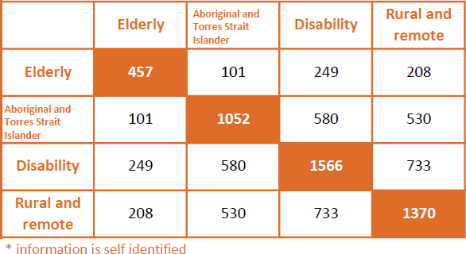

3a. SCHEME ACCESSIBILITY
3b. SCHEME INTERSECTIONALITY
applicants aged 70 or older
15%

34%
applicants who identify as Aboriginal or Torres Strait Islander

%
50%
applicants who have a disability

Priority Area 3:
Equity of Access
The Scheme recognises the unique sensitivities and considerations of the various survivor demographics

and seeks to promote equitable access to legal and support services.
Commentary
Intersectionality demonstrates how different survivor cohorts overlap and highlights the unique demographic of the survivor cohort.

For example, 733 applicants self identified as both having a disability and living in a rural or remote location.

The support services offered are culturally and linguistically diverse, noting the diversity of applicants in the Scheme.
applicants who live in a rural or remote location
44%
This data is as at 30 September 2020 for the 3,123 applications
received between 01 July 2019
and 30 June 2020

Metric: The number of survivors who successfully lodge an application with the Scheme each year, published according to survivor demographics, such as participation by Aboriginal and Torres Strait Islander / rural and remote / disabled / elderly.

9

3c. SUPPORT SERVICE ACCESSIBILITY
SUPPORT SERVICE ACCESSIBILITY
8%
of applicants are aged 70 or older
and used a Redress Support Service (RSS)

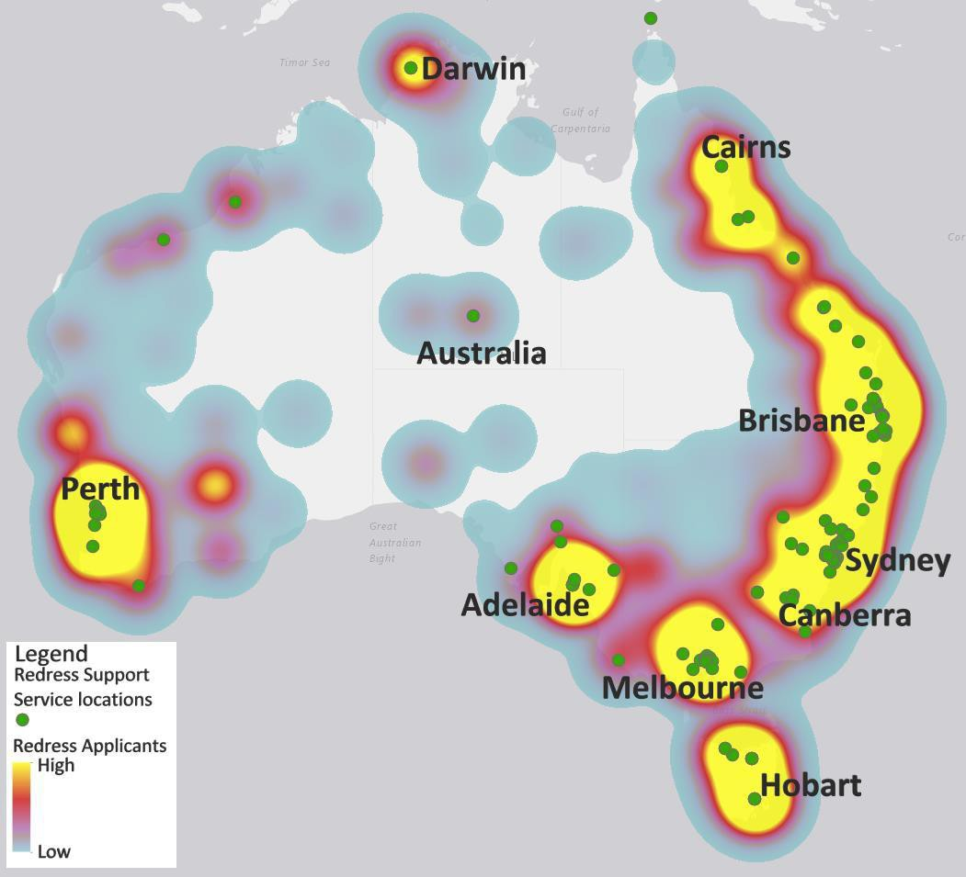
HEATMAP

of applicants identify as Aboriginal and Torres Strait Islander and used an RSS
15%

15%

Priority Area 3:
Equity of Access
28%
of applicants have a disability and
used an RSS

18%
of applicants live in a rural or
remote location and used an RSS

Commentary
The Support Services Accessibility Heatmap shows the concentration of applicants to the Scheme, and their proximity to Redress Support Services, including knowmore.

Redress Support Services offer face-to-face and/or phone/video support to meet the diverse needs of applicants. Many also conduct outreach to support people to apply from rural and remote locations.

The Scheme will continue to focus on addressing service gaps and needs, enable specialist support for diverse client cohorts, and increase outreach to assist people to apply in regional and remote locations.

10

Metric: Accessibility of the Scheme’s support services to all survivor demographics, such as participation by Aboriginal and Torres Strait Islander / rural and remote / disabled / elderly.

*the percentages above represent 1,206 out of 3,123 of applicants who indicated that they used a Redress Support Services, including knowmore, in preparing their application

(cont.)
The Scheme recognises the unique sensitivities and considerations of the various survivor demographics and seeks to promote equitable access to legal and support services.
This data is as at 30 September 2020 for the 3,123 applications
received between 01 July 2019 and 30 June 2020*

Going forward
In coming months, the Scheme sees another key date for its operation.

31 December 2020 marks the next date where the Minister for Families and Social Services will again publicly
name further institutions who have failed to join the scheme in the last six months.

Clearly, a key focus of the Scheme in its second year of operation was to process the large number of applications received in the first year (ie applications lodged prior to 1 July 2019 ). The older applications were prioritised over new applications received during this time, which has contributed to not achieving the target of issuing 80% of outcomes within 6 months of receipt. Around 2,537 applications received in the first year have now been finalised. While there is a small residual number of older claims currently being actioned, the department anticipates the timeliness of application processing will continue to improve.

Going forward, the priority before 31 December is to assist and on board as many institutions as possible to ensure more pending applications can be processed, and survivors of abuse offered redress payments.

The Government remains committed to utilising serious financial levers, further emphasised by the Prime Minister at the 2nd anniversary of the National Apology to Victims and Survivors of Institutional Child Sexual Abuse. This will see no publically named institution receive Commonwealth Government Funding into the future, and have their charitable status removed.

The department will continue to provide Strategic Success Measures through the implementation arrangements of the Intergovernmental Agreement on the National Redress Scheme for Institutional Child Sexual Abuse, on a six monthly basis.

11

Appendix
Survivor Experience

1a. Application Timeliness
- 262 applicants (10%) received an outcome within 6 months of the date the application was received or the date all the institutions named in the application opted into the Scheme. Comparative period 2018-19: 367 applicants representing 11% of applicants.
- 731 applicants (27%) received an outcome within 9 months of the date the application was received or the date all the institutions named in the application opted into the Scheme. Comparative period 2018-19: 610 applicants representing 19% of applicants.
- 1244 applicants (46%) received an outcome within 12 months of the date the application was received or the date all the institutions named in the
application opted into the Scheme. Comparative period 2018-19: 733 applicants representing 23% of applicants.

1b. Application Progress Summary
- 47% of applications where no outcome has been issued against the number of applications received as at reporting date and are not on hold. Comparative period 2018-19: 61%.
- 11% of applications on hold against the number of applications received as at reporting date. Comparative period 2018-19: 20%.
- 42% of applications with an outcome issued against the number of applications received as at reporting date. Comparative period 2018-19: 19%.

1c. Survivor Journey
- Nil results.
Health of the Scheme 2a. Survivor Acceptance
- 985 applicants (77%) who have been issued an outcome have responded to their offer of redress and have accepted the offer of redress.
Comparative period 2018-19: 629 applicants representing 83% of applicants.
- 692 applicants (54%) who have been issued an outcome have responded requesting counselling and psychological care (CPC), either in the form of a CPC referral or a payment. Comparative period 2018-19: 397 applicants representing 52% of applicants.
- 575 applicants (45%) who have been issued an outcome have requested a direct personal response from at least 1 institution that was found responsible for the abuse. Comparative period 2018-19: 337 applicants representing 44% of applicants.
- 289 applicants have not yet responded to their offer of redress. Less than 10 applicants have declined their redress offer during the period. Comparative period 2018-19: 28 applicants representing 4% of applicants.

2b. Maintaining Institutional Participation
- 272 NGIs have opted into the Scheme, in addition to all Commonwealth, state and territory institutions. 10 institutions have been on boarded into the Scheme under the Funder of Last Resort arrangement.
- 545 applications are on hold due to an institution not opted into the Scheme.
- 0 institutions have left the Scheme.

12

Appendix (cont.)
Equity of access

3a. Scheme Accessibility
- Scheme demographics information, including Aboriginal or Torres Strait Islander and Disability indicators, are based on the information that has been provided on the application form by the applicant.
- 457 applicants are aged greater than 70 years old at the time their application was received.
- 1,052 have self identified in the application form that they identify as Aboriginal or Torres Strait Islander.
- 1,566 have self identified in the application form that they have a disability.
- 1,370 applicants are from a rural or remote area based on their residential postcode.

3c. Support Service Accessibility
- The use of a Redress Support Service, as well as Scheme demographics information, including Aboriginal or Torres Strait Islander and disability indicators, are based on the information provided on the application form by the applicant.
- 238 applicants are aged greater than 70 years old at the time their application was received and used a Redress Support Service in preparing their application.
- 470 have self identified in the application form that they identify as Aboriginal or Torres Strait Islander and used a Redress Support Service in preparing their application.
- 865 have self identified in the application form that they have a disability and used a Redress Support Service in preparing their application.
- 564 applicants are from a rural or remote area based on their residential postcode and used a Redress Support Service in preparing their application.

13

