National Redress Scheme – for people who have experienced institutional child sexual abuse

Strategic Success Measures July 2021

Key operating data: Redress Applications
As at 31 March 2021, the total number of applications received by the Scheme increased by 2,720 (37 per cent) from the previous reporting period of 1 July 2019 to 30 June 2020. This brings the total number of redress applications to 10,047.
As at 31 March 2021, over 1,500 unique institution sites (for example, individual schools, orphanages, church groups) have been found responsible for abuse, resulting in approximately 5,275 redress payments totalling approximately $445 million.
In the 12 months from 1 April 2020 – 31 March 2021:
- 3,497 people applied for redress through the Scheme
- 4,028 people were assessed as eligible for redress
- 134 applications were assessed as ineligible
- 3,759 people accepted an offer of redress
- Fewer than five people declined offers of redress
- 3,738 applications were finalised, including 3,722 redress payments ranging from less than $10,000 to $150,000 with an average payment of $85,806
- the total value of redress monetary payments was $319,370,902

Key operating data: Redress Outcomes
In the 12 months from 1 April 2020 – 31 March 2021:
- 2,638 people requested counselling and psychological care as part of their redress outcomes
- 2,110 people requested a direct personal response
- 68 per cent of applications name more than one institution in their application and 25 per cent of applications name four or more institutions
- Substantial improvements in application processing have been made:
  - From 1 April 2020 – 31 March 2021, the Scheme delivered 4,119 outcomes, giving an average of 343 outcomes per month over the period.
  - By comparison, from 1 July 2019 – 30 June 2020, the Scheme delivered 3,092 outcomes, giving an average of 258 outcomes per month over the period.
  - From 1 April 2020 – 31 March 2021, the Scheme finalised a total of 3,738 applications, giving an average of 312 per month over the period.
  - By comparison, at 30 June 2019 (after 1 year of operation), the Scheme had finalised a total of 239 applications, giving an average of 20 per month over the period.

Priority Area 1: Survivor Experience
This measures focuses on the time it takes for the Scheme to process an application.
This data relates to data at 31 March 2021 for the 1,916 outcomes issued relating to 3,223 applications received between 1 October 2019 and 30 September 2020.

1a. Application Timeliness

The data is an improvement on the figures from the Scheme’s first success measures (October 2020) where 10 per cent of outcomes were advised within 6 months of receipt, 27 per cent within 9 months of receipt and 46 per cent within 12 months of receipt.

Application progression times have benefited from greater resourcing provided by the Australian Government for more Independent Decision Makers, however many applications can still not be finalised within 6 months due to delays with organisations, inability to contact applicants or nominees or where the applicant has put the application on hold.
Data from graphic:
61 per cent of outcomes advised within 12 months of application receipt
47 per cent of outcomes advised within 9 months of application receipt
21 per cent of outcomes advised within 6 months of application receipt
Metric: at least 80 per cent of applications that name institutions that participate in the Scheme have a decision communicated to the applicant within six months of being received by the Scheme

Commentary

Substantial improvements in application processing have been made. From 1 October 2019 to 30 September 2020 the Scheme finalised a total of 3,149 applications, giving an average of 262 per month over the period.

A key focus of the Scheme in its second year of operation was to process the large number of applications received in the first year (that is, applications lodged prior to 1 July 2019).

The older applications were prioritised over new applications received during this time, which has contributed to not achieving the target of issuing 80 per cent of outcomes within 6 months of receipt.

3,089 applications received in the first year have now been finalised. While there is a small residual number of older claims currently being actioned, the department anticipates the timeliness of application processing will continue to improve.

The Scheme was impacted by the COVID-19 pandemic in a number of ways, including telephony disruption, and the time it took institutions to respond to requests for information.

Priority Area 1: Survivor Experience (continued)

This measures focuses on the time it takes for the Scheme to process an application.

This data is current as at 31 March 2021 for the life of the Scheme.

1b. Application Progress Summary
Each application requires a number of steps to be undertaken prior to an offer being able to be advised.
These steps include: Validating application, preparing request for information (RFI), waiting for RFI response, validate RFI response, further application checks, determination, preparation of the offer and advising of offer.
The RFI step includes time with the institution (4 or 8 weeks) and the determination step includes time for the IDM to make their assessment.
An application will be declared as ‘in progress’ at all points during these steps, until the application is finalised.
Applications can be on hold for various reasons, for example: there is no participating institution; the Scheme is unable to identify the institution; the applicant has requested to be put on hold; the applicant is not contactable; documents are missing; or the applicant is under 18 years of age.
Applications can also be in progress for a substantial period of time while an applicant determines whether or not they will accept the offer. This is outside the Scheme’s control.
Redress Support Services are available through all stages of the application to assist applicants and their nominees.
Data from graphic:
31 per cent of applications are in progress.
60 per cent of applications have had an offer advised to the applicant.
9 per cent of applications are on hold.
Metric: at least 80 per cent of applications that name institutions that participate in the Scheme have a decision communicated to the applicant within six months of being received by the Scheme.

Commentary
This data represents significant improvement in application progression compared to the October 2020 report.
31 per cent of applications are in progress, compared with 47 percent. This correlates with the increased efforts of the Scheme to finalise the legacy cases.
60 per cent of all applicants have had their offer advised, compared with 42 per cent.
The Scheme has fewer applications on hold – 9 per cent compared to 11 per cent.

Priority Area 1: Survivor Experience (continued)

1c. Survivor Journey
Survivors are central to the Scheme and all decision making around its improvements.
The trauma experienced by survivors must be recognised.
In the second half of 2020, the department engaged Whereto Research to consult with appropriate stakeholders and develop a survey to report on the survivor journey. The department and Whereto Research developed and tested a survey approach/instrument to ensure it is trauma informed, safe and respectful for survivors.
The redress survivors survey, part of the measure for the survivor journey, was conducted in March 2021. The survey has seen low uptake among survivors, and as a result there are not enough responses to the survey to be statistically valid.
To address the low participation in the survey, the Scheme has amended the acceptance documents inviting survivors to opt-in to the survivor survey. The survey will be more accessible, better communicated and promoted. The Scheme believes this will increase uptake for the new survey.
Outside the survivor journey survey, the Scheme continues to gather feedback from survivors, nominees and support services as to how the Scheme is operating, and will continue to do so.
Metric: Survivor experience with the process of the Scheme, including Scheme responsiveness, degree of respectful, dignified, knowledgeable and trauma-informed interactions, ease of understanding, level of proactivity, consistency of service quality.

Priority Area 2: Health of the Scheme
This measure provides an insight into the overall performance of the Scheme, particularly in regard to the participation of institutions.
This data is current as at 31 March 2021for the life of the Scheme

2a. Survivor Acceptance

If the Scheme approves a person’s application for redress, the Scheme must do so in a written form that explains the three components of redress (redress payment, access to counselling, and direct personal response), the amount of offer, the date of the offer, the acceptance period and informs the applicant that they do not need to accept the offer, but that it will be taken to be declined at the end of the acceptance period.

The acceptance period for the redress offer is 6 months, however this can be extended in circumstances.

While an applicant can access support services during the 6 month acceptance period, the Scheme as a whole is not involved in the decision making process.

Detailed in the data below, 88 per cent of offers were accepted by applicants in the reporting period, however approximately 12 per cent of offers have not yet been responded to by applicants. This means these applicants are yet to make a decision on whether to accept, decline, seek a review or request an extension to consider the offer.
Data from graphic:
88 per cent of applicants accepted their offer of redress
60 per cent of applicants accepted an offer of Counselling and Psychological Care
49 per cent of applicants requested a Direct Personal Response (DPR) from an institution
Less than one per cent of applicants declined their offer of redress
Metric: The percentage of redress offers accepted by survivors across redress payments, DPR and counselling
Commentary
This data represents significant improvements from the October 2020 report: more applicants are accepting their redress offers (88 per cent compared to 77 per cent); more applicants are accepting their Counselling and Psychological Care offer (60 per cent compared to 54 per cent); and more applicants are requesting a Direct Personal Response (49 per cent compared to 45 per cent).

Priority Area 2: Health of the Scheme (continued)

This measure provides an insight into the overall performance of the Scheme, particularly in regard to the participation of institutions.

This data is current as at 31 March 2021 for the life of the Scheme.

2b. Maintaining Institutional Participation
As at 31 March 2021, the Commonwealth, all state and territory governments and 459 non-government institutions are participating in the Scheme, covering more than 62,900 sites.
These figures increased substantially between the first and second years of the Scheme. The number of non-government institutions participating increased from 47 as at 30 June 2019 to 272 as at 30 September 2020, to 459 as at 31 March 2021.
The Minister and department continue to focus on encouraging institutions to join where they have been named in applications to the Scheme or in the Royal Commission into institutional responses to child sexual abuse.
This includes through the introduction of measures to remove the charitable status of institutions not signed onto the Scheme, and/or prevent such institutions from accessing Commonwealth grant funding.
Institutions named in applications or the Royal Commission that do not join the Scheme will be publicly named and may face financial penalties. The first group of institutions were publicly named on the Scheme’s website on 1 July 2020.
Data from graphic:
1 Non-Government Institutions publicly named
459 Non-Government Institutions have opted into the Scheme.
203 applications on hold due to institutions not opted in.
7 institutions have left the Scheme*.
* None of the institutions that have left the Scheme were named by the Royal Commission, nor have any of them have been named in Redress applications.
Metric: Scheme participation by institutions.

Priority Area 3: Equity of Access

The Scheme recognises the unique sensitivities and considerations of the various survivor demographics and seeks to promote equitable access to legal and support services.

This data is current as at 31 March 2021 for the life of the Scheme.

3a. Scheme Accessibility
Data from graphic:
19 per cent applicants aged 70 or older.
31 per cent applicants who identify as Aboriginal or Torres Strait Islander.
48 per cent applicants self-identify as living with a disability*.
45 per cent applicants who live in a rural or remote location.
* disability is not a term defined by the Scheme. Applicants may self-identify as having a disability which includes illness and age-related conditions.

Metric: The number of survivors who successfully lodge an application with the Scheme each year, published according to survivor demographics, such as participation by Aboriginal and Torres Strait Islander / rural and remote / disabled / elderly.

3b. Scheme Intersectionality
Table (modified for accessibility):
 | Elderly | Aboriginal and Torres Strait Islander | Disability | Rural and remote
Elderly | 1,906* | 421 | 1,002 | 880
Aboriginal and Torres Strait Islander | 421 | 3,089 | 1,609 | 1,626
Disability | 1,002 | 1,609 | 4,788 | 2,278
Rural and remote | 880 | 1,626 | 2,278 | 4,511

*Aboriginal and Torres Strait Islander elderly are defined as aged 50 or older, whereas for all other applicants it is 70 or older.

Commentary

Intersectionality demonstrates how different survivor cohorts overlap and highlights the unique demographic of the survivor cohort.

For example, 2,278 applicants self identified as both having a disability and living in a rural or remote location.

The support services offered are culturally and linguistically diverse, noting the diversity of applicants in the Scheme.

Priority Area 3: Equity of Access (continued)

The Scheme recognises the unique sensitivities and considerations of the various survivor demographics and seeks to promote equitable access to legal and support services.

This data is current as at 31 March 2021 for the life of the Scheme.

3c. Support Service Accessibility
Data from graphic:
8 per cent of applicants are aged 70 or older and used a Redress Support Service (RSS).
12 per cent of applicants identify as Aboriginal and Torres Strait Islander and used an RSS.
22 per cent of applicants have a disability and used an RSS.
14 per cent of applicants live in a rural or remote location and used an RSS.
Metric: Accessibility of the Scheme’s support services to all survivor demographics, such as participation by Aboriginal and Torres Strait Islander / rural and remote / disabled / elderly.
*the percentages above represent 3,108 applicants who indicated that they used a Redress Support Services, including knowmore, in preparing their application, out of 10,047 applications received by the Scheme.

Commentary

The Support Services Accessibility Heat map (next page) shows the concentration of applicants to the Scheme, and their proximity to Redress Support Services.

Redress Support Services offer face-to-face and/or phone/video support to meet the diverse needs of applicants. Many Services conduct outreach to support people to apply from rural and remote locations.

The Scheme will continue to focus on addressing service gaps and needs, enable specialist support for diverse client cohorts, and increase outreach to assist people to apply in regional and remote locations.

Graphic: Support Service Accessibility Heatmap
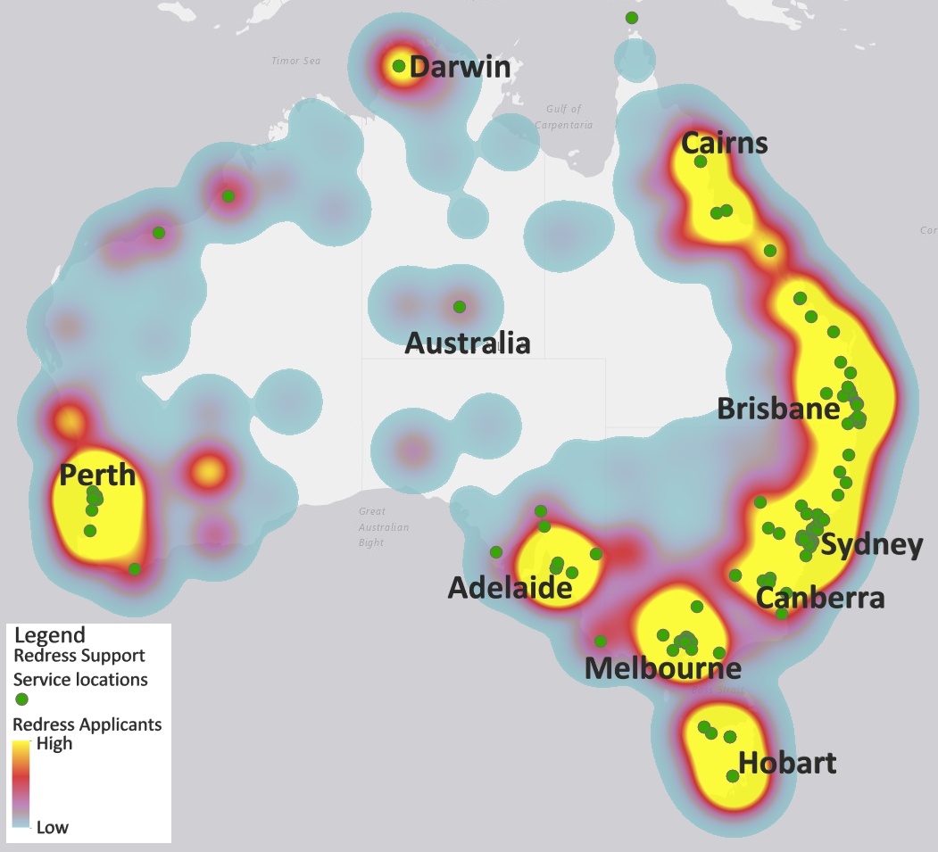

Going forward

The Scheme continues to improve. The success measures are important in tracking improvement and ensuring accountability. The data in this second Strategic Success Measures report represents an improvement in the Scheme’s second year of operation compared to the first year.

From 1 January 2021, when the Scheme receives an application that names an institution which had not been previously named, that institution will have a period of six months from their first engagement to join the Scheme. Failure to join the Scheme within six months means that such institutions may be publicly named, will have financial sanctions applied and may lose their charitable status until they join the Scheme.

Jehovah's Witnesses, Kenja Communications and Fairbridge Restored Limited were named on 1 July 2020 having not joined the Scheme or signified an intent to join. Jehovah’s Witnesses have begun the process of onboarding into the Scheme, and in March 2021, applications relating to the five former Fairbridge Farm schools are covered under the funder of last resort provisions. The Scheme will continue to work towards ensuring as few applications are on hold due to an institution not being signed onto the Scheme as possible. A further 23 defunct institutions are currently being considered under funder of last resort provisions.

One of the key priorities for the Scheme is responding to the Second Anniversary Review of the National Redress Scheme (final report released June 2021). The Government is taking immediate action on 25 of the 38 recommendations. The independent reviewer met with and received submissions from government stakeholders, non-government institutions, support services and survivors. The Review identified significant success in areas of the Scheme and also made recommendations for improvements to the survivor experience.

Appendix A
Application Timeliness Table
Column 1: As at 30 September 2020, relating to applications received between 1 July 2019 to 30 June 2020.
- 10 per cent received an outcome within 6 months of the date the application was received or the date all the institutions named in the application opted into the Scheme.
- 27 per cent received an outcome within 9 months of the date the application was received or the date all the institutions named in the application opted into the Scheme.
- 46 per cent received an outcome within 12 months of the date the application was received or the date all the institutions named in the application opted into the Scheme.
Column 2: As at 31 March 2021, relating to applications received between I October 2019 to 30 September 2020.
- 21 per cent received an outcome within 6 months of the date the application was received or the date all the institutions named in the application opted into the Scheme.
- 47 per cent received an outcome within 9 months of the date the application was received or the date all the institutions named in the application opted into the Scheme.
- 61 per cent received an outcome within 12 months of the date the application was received or the date all the institutions named in the application opted into the Scheme.

Appendix B

Application Progress Summary Table
Column 1: As at 30 September 2020, relating to applications received between 1 July 2019 to 30 June 2020.
- 47 per cent of applications where no outcome has been issued against the number of applications received and are not on hold.
- 11 per cent of applications on hold against the number of applications received as at reporting date.
- 42 per cent of applications with an outcome issued against the number of applications received as at reporting date.
Column 2: As at 31 March 2021, relating to applications received between I October 2019 to 30 September 2020.
- 31 per cent of applications where no outcome has been issued against the number of applications received and are not on hold.
- 9 per cent of applications on hold against the number of applications received as at reporting date.
- 60 per cent of applications with an outcome issued against the number of applications received as at reporting date.

Appendix C

Outcome acceptance summary table
Column 1: As at 30 September 2020 for the life of the Scheme.
- 985 applicants who have been issued an outcome have responded to their offer of redress and have accepted the offer of redress.
- 692 applicants who have been issued an outcome have responded requesting counselling and psychological care (CPC), either in the form of a CPC referral or a payment.
- 575 applicants who have been issued an outcome have requested a direct personal response from at least one responsible institution.
- 289 applicants who have not yet responded to their offer of redress.
Column 2: As at 31 March 2921 for the life of the Scheme.
- 1,594 applicants who have been issued an outcome have responded to their offer of redress and have accepted the offer of redress.
- 1,175 applicants who have been issued an outcome have responded requesting counselling and psychological care (CPC), either in the form of a CPC referral or a payment.
- 956 applicants who have been issued an outcome have requested a direct personal response from at least one responsible institution.
- 296 applicants who have not yet responded to their offer of redress.

Appendix D

Institutional Engagement Table
Column 1: As at 30 September 2020 for the life of the Scheme.
- 272 NGIs have opted into the Scheme, in addition to all Commonwealth, state and territory institutions.
- 10 institutions have been on boarded into the Scheme under the Funder of Last Resort arrangement.
- 545 applications are on hold due to an institution not opted into the Scheme.
- 0 institutions have left the Scheme.
Column 2: As at 31 March 2021 for the life of the Scheme.
- 459 NGIs have opted into the Scheme, in addition to all Commonwealth, state and territory institutions.
- 23 institutions have been on boarded into the Scheme under the Funder of Last Resort arrangement.
- 203 applications are on hold due to an institution not opted into the Scheme.
- 7 institutions have left the Scheme.
- 564 applicants are from a rural or remote area based on their residential postcode and used a Redress Support Service in preparing their application.

END OF REPORT

