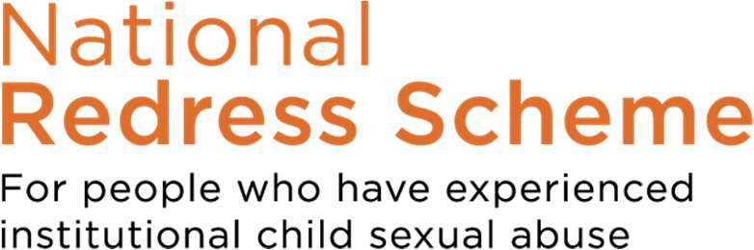

FACT SHEET

DIRECT PERSONAL RESPONSE

What is a direct personal response?
A direct personal response is one of three components of redress that may be offered under the National Redress Scheme (a financial payment, access to counselling and a direct personal response).
Direct personal response is between the survivor and a representative of the institution/s responsible for the abuse. It will usually involve:
- An acknowledgement of your personal experience, and the impact the abuse has had on you
- An apology
- An explanation by the institution(s) on what they have done, or will do, to stop abuse from happening again.
A direct personal response can be done in a variety of ways, such as:
- a face-to-face meeting between you and a representative of the institution
- a written letter from the institution, or
- other arrangements, depending on your circumstances.
It is important for you to decide whether a direct personal response is right for you. It could be helpful to speak to a support person, such as a friend, family member, counsellor, or Redress Support Service to help you make this decision. You can find a list of Redress Support Services at www.nationalredress.gov.au/support.

How does it work?
If you receive an offer of redress, and want to accept all components of your redress offer, you just need to sign the acceptance document.
The Scheme will then send you details of the contact person(s) at the responsible institution(s) who will work with you to arrange your direct personal response. You, or your support person, can contact the institution’s contact person when you feel ready to start discussing what you would like to happen in your direct personal response. You can do this at any time up until the end of the Scheme (i.e. 30 June 2028).
You can choose to have a support person with you at any time during the direct personal response process.
The Scheme also has a Direct Personal Response Information and Support team who can provide you, or your support person, with more information about direct personal response – what it is, what it can involve and what it might look like for you. The team can also help you to contact the institution, or connect you with a Redress Support Service.

Can I change my mind?
Receiving a direct personal response from the institution is always your choice.
Even if you request a direct personal response when you accept your offer, you can delay the process or stop it altogether at any time.
You can choose not to accept the offer of a direct personal response, if you wish. However, if you do this, you cannot change your mind later on.

How do I contact the Scheme DPR Information and Support team?
You can contact the DPR Information and Support team at any time while your application is progressing - while you consider your redress outcome or after you have accepted your redress offer of a direct personal response.
Call the Scheme on 1800 737 377 and ask to speak to DPR Information and Support.
How can I get support?
Those who need immediate emotional support can contact:
- Beyond Blue 1300 22 4636
- Lifeline 13 11 14
- 1800 Respect 1800 737 732
- Suicide Call Back Service 1300 659 467
- Mensline 1300 78 99 78
- In an emergency call Triple Zero (000)

