



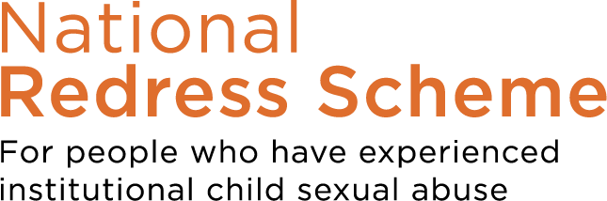

Published XX October 2022

`

FACT SHEET

TAKING THE NATIONAL REDRESS SCHEME JOURNEY

What is the National Redress Scheme?

The National Redress Scheme has been set up to help those people who were sexually abused in institutions. It is to acknowledge what was done, the harm it has caused and the ways it has affected your life.

The National Redress Scheme can help you get access to three things:

- counselling
- a redress payment
- a direct personal response from an institution (e.g. an apology).
If you receive an offer of redress, you can accept any or all of these things. This is your choice.

Many people will need help to take the redress journey. Help to know what’s involved, help to decide whether to begin this journey, help to decide if it is the right path for me and help to understand what happens at the end of the journey.

1

What help is available?

There are three different kinds of support services to help you on the journey. You can use one or all of these, and they are all free for you to use.

- Redress Support Services - to help guide you through every part of your journey. There are both mainstream and Aboriginal and Torres Strait Islander specific services.
- Legal Support - to help you to understand what the various paths that you could take are, and help you decide which path is best for you. This is provided by a service called knowmore and they have Aboriginal workers if you want to yarn with an Aboriginal person. You can call knowmore on 1800 605 762.
- Financial Counselling - to help you understand how to protect your payment and manage your debts. knowmore provides this service too, and you can call them on 1800 605 762 to find out more information.

Getting help from a trusted person

The Redress Journey could be a hard one, and you might decide you would like another person to speak and act for you. This is called a Nominee. This person might be a trusted friend or relative or could be your support worker. If you want them to speak for you with the Redress Scheme you need to fill in the Nominee Form.

Finding a support service

There are both mainstream and Aboriginal and Torres Strait Islander support services available in every state and territory with the exception of the ACT. If you are in the ACT and are seeking an Aboriginal and Torres Strait Islander specific support service, please contact Link-Up NSW or Kinchela Boys Home Aboriginal Corporation.

Published XX October 2022

2


Aboriginal and Torres Strait Islander Support Service Providers

ACT and NSW | Link-Up (NSW) Aboriginal Corporation | www.linkupnsw.org.au  1800 624 332 or 02 9421 4700 (for  mobiles)
NSW | Kinchela Boys Home Aboriginal Corporation | kinchelaboyshome.org.au  02 9051 1690
Northern Territory | Northern Territory Stolen Generations Aboriginal Corporation | www.ntsgac.org.au 08 8947 9171
Queensland | Link-Up (QLD) Aboriginal Corporation | www.link-upqld.org.au 1800 200 855
 | Cape York/Gulf Remote Area Aboriginal & Torres Strait Islander Child  Care Advisory Association | www.raatsicc.org.au  07 4030 0900 or 1300 663 411
 | Murrigunyah Aboriginal and Torres Strait Islanders Corporation for Women | www.murrigunyah.org.au 07 3299 5525
South Australia | Nunkuwarrin Yunti of South Australia Incorporated | https://nunku.org.au 08 8406 1600
Victoria | Connecting Home | connectinghome.org.au  03 8679 0777
Western Australia | Yorgum Aboriginal Corporation | www.yorgum.org.au  08 9218 9477 or 1800 469 371
 | Kimberley Stolen Generation Aboriginal Corporation | www.kimberleystolengeneration.com.au 1800 830 338
 | Aboriginal Family Legal Service | www.afls.org.au  08 9355 1502
Tasmania | South East Tasmanian Aboriginal Corporation | setac.org.au 03 6295 0004

Published XX October 2022
3

You can find additional support services in your area by visiting the National Redress website www.nationalredress.gov.au or calling the National Redress Scheme on 1800 737 377.

National crisis numbers
Lifeline
13 11 14 — 24/7 crisis support and suicide prevention services. To find local services in your area use Lifeline's Service Finder.
Suicide Call Back Service
1300 659 467 — 24/7 telephone crisis support for people at risk of suicide, carers and bereaved, as well as online resources and information
Kids Helpline
1800 55 1800 — 24/7 telephone counselling for young people 5 to 25 years
MensLine Australia
1300 78 99 78 — 24/7 telephone and online support, information and referral service for men
beyondblue

1300 22 4636 — 24/7 telephone support service and online chat 4pm - 10pm (AEST)
Published XX October 2022
4

