The National Redress Scheme’s Strategic Success Measures
June 2026

Contents
The National Redress Scheme’s Strategic Success Measures 0
About this document 2
Disclaimer: 2
Metrics 2
The Survivor Journey Metric 2
Redress Payment Metric 2
Application Timeliness Metric 2
Survivor Acceptance Metric 2
Quality Decision Making Metric 2
Scheme Accessibility Metric 2
Key operating data: Redress Applications 3
Priority Area 1: Survivor Experience 4
1a. The Survivor Journey 4
1b. Advance Payment 5
1c. Redress Payment 6
1d. Application Timeliness 7
Priority Area 2: Health of the Scheme 10
2a. Survivor Acceptance 10
2b. Maintaining Institutional Participation 11
2c. Quality Decision Making 12
Priority Area 3: Equity of Access 13
3a. Scheme Accessibility 13
3b. Support Service Accessibility 15

About this document
The National Redress Scheme (the Scheme) is committed to transparency and providing publicly available data about our performance. The Scheme’s Strategic Success Measures provide survivors and the broader community an indication of how the Scheme is performing across three priority areas:
- survivor experience,
- health of the Scheme and,
- equity of access.
This report includes additional information about the timeliness of application processing, and the number of applications on hand with the Scheme.
Disclaimer: this document contains data on applications that were received from the start of the Scheme to 30 June 2026.

Metrics
The following metrics are referenced throughout this document to showcase the Scheme’s performance and progress:

The Survivor Journey Metric
Survivor experience with the process of the Scheme, including Scheme responsiveness, a degree of respectful, dignified, knowledgeable and trauma-informed interactions, ease of understanding, level of pro-activity, and consistency of service quality.

Redress Payment Metric
The Scheme will issue ≥80% of eligible survivors with a redress payment within 14 days of receiving acceptance documentation.

Application Timeliness Metric
At least 75% of applications that name institutions that participate in the National Redress Scheme (Scheme) will have a decision communicated to the applicant within 6 months of all necessary information being received by the Scheme.

Survivor Acceptance Metric
This metric measures the percentage of redress offers accepted by survivors across Direct Personal Responses and Counselling and Psychological Care services.

Quality Decision Making Metric
The Scheme will maintain quality decision-making, with ≥95% of initial determinations reflecting the final outcome.

Scheme Accessibility Metric
The number of survivors who successfully lodge an application with the Scheme each year, published according to survivor demographics, such as participation by First Nations / rural and remote / people with disability / the elderly.

Key operating data: Redress Applications
As at 30 June 2026, 82,381 applications had been received by the Scheme. Of these:
- 29,666 applicants have had outcomes advised and 26,447 applications were finalised.
- Since the start of the Scheme, 23,214 payments were made totalling approximately $2.06 billion, with an average payment amount of $88,111.
- 47,174 applications are yet to have their outcomes advised. Of these:
  - 30,566 applications are actionable by the Scheme.
  - 9,690 are unable to be actioned by the Scheme.
  - 6,918 applications were on hold (for reasons such as at the request of the applicant, due to a non-participating institution, or difficulty in contacting the applicant)
- 4,118 applications had been withdrawn.
- 630 applications are undergoing reviews.
- 3,537 advance payments had been made.
- Approximately 965,673 calls had been made to the Scheme.

Priority Area 1: Survivor Experience

1a. The Survivor Journey
Metric: Survivor experience with the process of the Scheme, including Scheme responsiveness, degree of respectful, dignified, knowledgeable and trauma-informed interactions, ease of understanding, level of pro-activity, consistency of service quality.
In 2020, the Department engaged Where to Research to develop a trauma-informed, safe, and respectful survey to report on the survivor journey. Applicants were invited to participate in the survey through their letter of offer. The survey collected information about applicants’ experiences with the Scheme.
The number of people who responded to the survey was relatively small in proportion to the number of applicants who received an outcome during that period. Nevertheless, the survey responses provided valuable information to help the Scheme identify trends over time and how survivors felt about their interactions with the Scheme.
In the latest survey report, which covers responses received between September 2025 and January 2026, trends apparent in the survey responses include:
- Feedback continues to be largely positive.
- over 8 in 10 respondents found Scheme staff to be helpful and respectful.
- time taken to resolve applications regressed after steady improvement in previous waves.
- while most respondents reported having to follow up with the Scheme for updates, an increase of 11% to nearly half, did not, and
- satisfaction with overall quality of service increased.

Apart from the survivor survey, the Scheme receives feedback from survivors and other stakeholders through other avenues, including the survivor roundtable, correspondence and project specific consultation.

1b. Advance Payment
Metric: The Scheme will issue ≥80% of eligible survivors with an advance payment within 7 days of receiving acceptance documentation.
The legislative amendments introduced advance payments in October 2021. As such, figure 2 only captures data from the 2022-23 financial year onwards.
The following data was accurate as at 30 June 2026 and shows how the Scheme had delivered on the Advance Payment metric.
Figure 2 - Percentage of Advance Payments Issued within 7 Days of Receiving Acceptance Documents
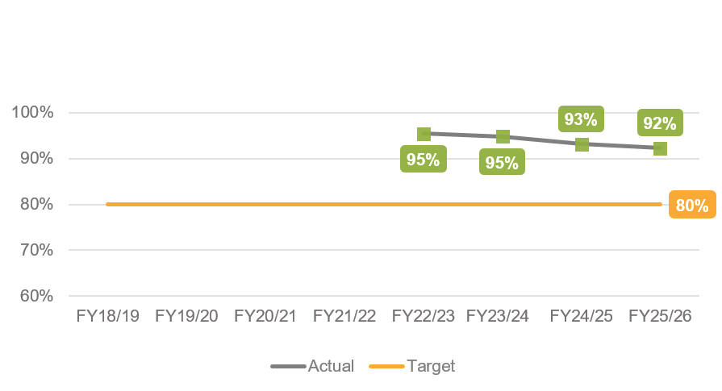
Result:
- 95% of advance payments were made within 7 days in 2022-23.
- 95% of advance payments were made within 7 days in 2023-24.
- 93% of advance payments were made within 7 days in 2024-25.
- 92% of advance payments were made within 7 days in 2025-26.
The above data indicates that the Scheme delivered on this metric.

1c. Redress Payment
Metric: The Scheme will issue ≥80% of eligible survivors with a redress payment within 14 days of receiving acceptance documentation.
The following data was accurate as at 30 June 2026 and captures how the Scheme had delivered on the Redress Payment metric each financial year from 2018-19.
Figure 3- Percentage of Payments Issued within 14 Days of Receiving Acceptance Documents.
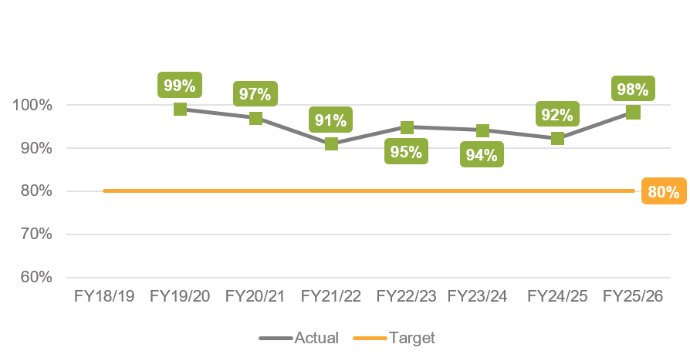
Results:
- 99% of redress payments made within 14 days in 2019-20.
- 97% of redress payments made within 14 days in 2020-21.
- 91% of redress payments made within 14 days in 2021-22.
- 95% of redress payments made within 14 days in 2022-23.
- 94% of redress payments made within 14 days in 2023-24.
- 92% of redress payments made within 14 days in 2024-25.
- 98% of redress payments made within 14 days in 2025-26.
The above data indicates the Scheme consistently delivered on this metric.

1d. Application Timeliness
Metric: At least 75% of applications that name institutions that participate in the National Redress Scheme (Scheme) will have a decision communicated to the applicant within 6 months of all necessary information being received by the Scheme.
The following data shows how the Scheme had delivered on the Application Timeliness metric each financial year from 2018-19 to 2025-26 to date. The data below was accurate as at 30 June 2026.
Figure 1 – Percentage of outcomes notified within 6 months of receiving all required information.
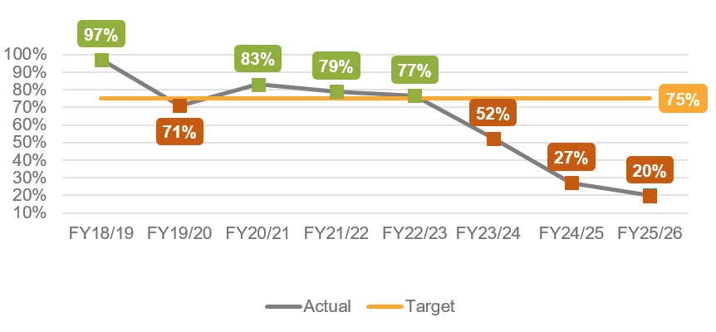
Results:
- 97% of outcomes notified within 6 months in 2018-19.
- 71% of outcomes notified within 6 months in 2019-20.
- 83% of outcomes notified within 6 months in 2020-21.
- 79% of outcomes notified within 6 months in 2021-22.
- 77% of outcomes notified within 6 months in 2022-23.
- 52% of outcomes notified within 6 months in 2023-24.
- 27% of outcomes notified within 6 months in 2024-25.
- 20% of outcomes notified within 6 months in 2025-26.
In 2025-26, 42% of outcomes were notified within 9 months and 70% of outcomes were notified within12 months (according to the same calculation method as in Figure 1).
The actual result for this measure has been decreasing since 2022-23, in large part due to the significant increase in the number of applications received in this period. The Scheme gives applicants and institutions additional opportunities to provide further information as part of the application process and this therefore takes additional time. Following the second-year review of the Scheme, measures were implemented to increase the finalisation rate of applications and enhance the accessibility of the Scheme. Several new initiatives were implemented in 2025-26 to increase the finalisation rate, including applications from the early years of the Scheme. While the Scheme has finalised a number of applications from the early years, this positive outcome is not able to be reflected in the number of applications finalised within 6 months.
As at 30 June 2026, the average processing time for applications was 16.6 months. The average processing time is calculated from when the Scheme first receives an application until the day that an applicant is notified of their outcome. It includes the time that the Scheme is waiting to receive information from the named institution(s) or further information from the applicant. This is a different calculation from the metric presented in Figure 1 above.

Table 1 – Application timeliness: long-term applications on hand

Scheme year received | FY 18/19 | FY 19/20 | FY 20/21 | FY 21/22 | FY 22/23 | FY 23/24 | FY 24/25 | FY 25/26
Applications received | 4,284 | 3,139 | 3,786 | 5,991 | 10,725 | 16,324 | 19,730 | 18,402
Since Withdrawn | 274 | 117 | 139 | 397 | 708 | 1,062 | 990 | 431
Since Closed | 130 | 38 | 46 | 36 | 115 | 283 | 688 | 87
Since Completed | 3,766 | 2,873 | 3,336 | 4,467 | 6,547 | 4,548 | 789 | 123
Currently On Hand | 114 | 111 | 265 | 1,091 | 3,355 | 10,431 | 17,263 | 17,761
Cumulative on hand | 114 | 225 | 490 | 1,581 | 4,936 | 15,367 | 32,630 | 50,391

How to read this data: This table presents the status of all applications received in each Scheme year, as at 30 June 2026 for example: 3,786 applications were received in 2020-21. Of those applications, 139 have since been withdrawn, 3,336 have since been finalised and 265 were still on hand at 30 June 2026.
*Note that a total of 5,381 applications were finalised in 2025-26 (not including closed or withdrawn applications).

Table 1 presents data on the length of time applications have been with the Scheme. Applications on hand from the first 2 years of the Scheme are as a result of a range of factors, including being on hold at the applicant’s request, the Scheme being unable to contact the applicant or due to non-participating institutions.

Table 2 – Applications finalised each Scheme year.
 | 2018-19 | 2019-20 | 2020-21 | 2021-22 | 2022-23 | 2023-24 | 2024-25 | 2025-26
Applications finalised | 235 | 2,539 | 3,274 | 2,768 | 3,846 | 4,008 | 4,136 | 5,381

Please note the data in this table may vary slightly from previously published figures, due to updates to data made over time. These figures do not reflect applications that have been closed or withdrawn.

Table 2 provides data on the total number of applications finalised in each year of the Scheme, regardless of which year they were received. The number of applications finalised in 2021-22 was affected by a process change which paused processing for a period. Other than that year, the number of finalised applications has increased each year.

The Scheme was established after the longest running Royal Commission in Australia. Modelling provided to the Royal Commission predicted 60,000 applications would be received over the 10 years of the Scheme.

Priority Area 2: Health of the Scheme

2a. Survivor Acceptance
Metric: This metric measures the percentage of redress offers accepted by survivors across Direct Personal Responses and Counselling and Psychological Care services.
The following data was accurate as at 30 June 2026:
- 17,586 (74%) of people who accepted an offer of redress, had also accepted the offer for Counselling and Psychological Care (CPC) services. Of these 12,653 (72%) were for referral services and 4,933 (28%) were for a lump sum payment.
- 13,759 (representing 58% of applicants who responded to their offer of redress) indicated that they may like to participate in a Direct Personal Response.

2b. Maintaining Institutional Participation
Metric: The Scheme will engage and maintain participation, with institutions on board to cover ≥95% of applications in progress.
The following data was accurate as at 30 June 2026 and captures how the Scheme had delivered on the Maintaining Institutions Participation metric.
Figure 4 – Percentage of on-board institutions covering applications in progress.
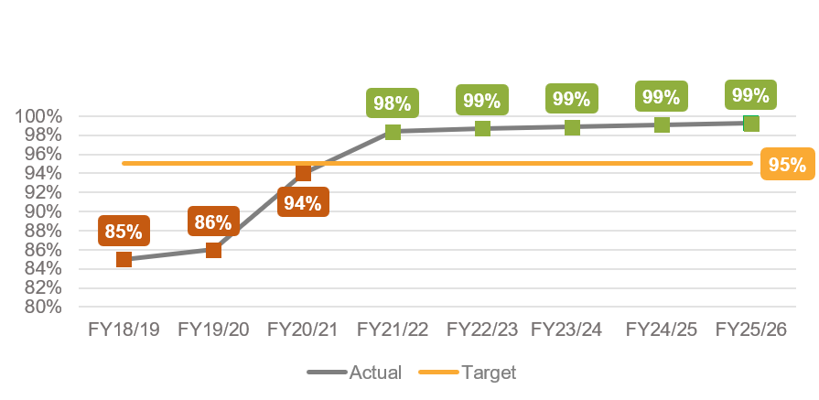
Results:
- 85% of applications have institutions on board in 2018-19.
- 86% of applications have institutions on board in 2019-20.
- 94% of applications have institutions on board in 2020-21.
- 98% of applications have institutions on board in 2021-22.
- 99% of applications have institutions on board in 2022-23.
- 99% of applications have institutions on board in 2023-24.
- 99% of applications have institutions on board in 2024-25.
- 99% of applications have institutions on board in 2025-26.
Since the beginning of the Scheme, significant progress was made to this objective. The Scheme delivered on this metric since 2021-22.

2c. Quality Decision Making
Metric: The Scheme will maintain quality decision-making, with ≥95% of initial determinations reflecting the final outcome.
The following data was accurate as at 30 June 2026 and captures how the Scheme has delivered on the Quality Decision Making metric.
Figure 5 – Percentage of initial determinations reflecting the outcome.

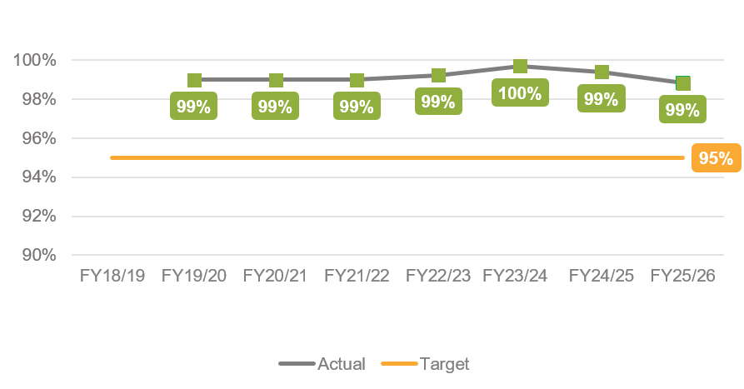
Results:
- 99% of initial determinations reflect the final outcome in 2019-20.
- 99% of initial determinations reflect the final outcome in 2020-21.
- 99% of initial determinations reflect the final outcome in 2021-22.
- 99% of initial determinations reflect the final outcome in 2022-23.
- 100% of initial determinations reflect the final outcome in 2023-24.
- 99% of initial determinations reflect the final outcome in 2024-25.
- 99% of initial determinations reflect the final outcome in 2025-26.
The Scheme consistently delivered on this metric with at least a 99% success rate. This measure of quality decision making considered the outcomes of the review process. Less than 1% of all initial determinations were changed at the review stage.

Priority Area 3: Equity of Access

3a. Scheme Accessibility
Metric: The number of survivors who successfully lodge an application with the Scheme each year, published according to survivor demographics, such as participation by First Nations / rural and remote / people with disability / the elderly.
As at 30 June 2026 the demographics of applicants over the life of the Scheme were:

Figure 6 - Gender of applicants
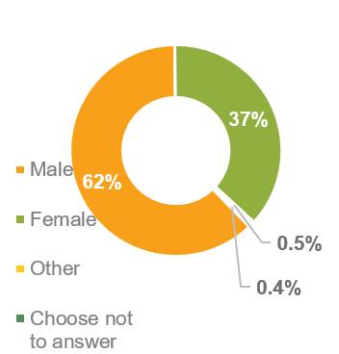
Figure 7 – Disability status
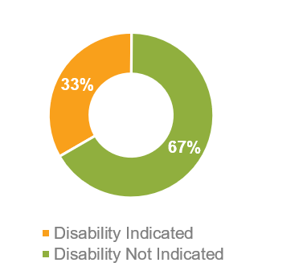

Figure 8 – Indigenous status
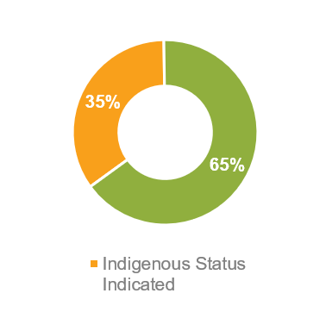
Figure 9 – Application method
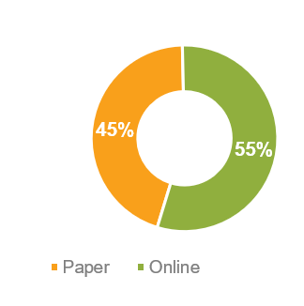

Scheme accessibility over the life of the Scheme as at 30 June 2026:
- 10% of applicants were elderly
- 35% of applicants identify as Aboriginal or Torres Strait Islander
- 33% of applicants self-identify as living with a disability
- 42% of applicants lived in a rural or remote location.
State of Residence of applicants as at 30 June 2026:
- National (includes overseas and unspecified numbers): 82,381.
- Australian Capital Territory: 836
- New South Wales: 19,004
- Northern Territory: 761
- Queensland: 27,563
- South Australia: 11,642
- Tasmania: 3,674
- Victoria: 8,507
- Western Australia: 9,996
- Overseas and Unspecified: 398

3b. Support Service Accessibility
Metric: Accessibility of the Scheme’s support services to all survivor demographics, such as participation by First Nations / rural and remote / people with disability / elderly.
Redress Support Services (RSS) are specialist, trauma-informed, culturally safe, survivor centred services. RSS provide free, confidential, practical and emotional support before, during and after people make, or consider making, an application to the National Redress Scheme. Many Services conduct outreach to support people to apply from survivor demographics.

Support Service Accessibility over the life of the Scheme as at 30 June 2026:
- Approximately 11% of applicants were supported by a RSS (excluding Knowmore Legal Service).
- Approximately 4% were supported by Knowmore Legal Service.
- 27% of applicants who identify as having a disability used a RSS.
- 18% of applicants who lived in a regional or remote location used a RSS.
- 21% of applicants who identified as First Nations used a RSS.
- 44% of elderly applicants at application used a RSS.
- 20% of applicants had nominees to assist them to engage with the Scheme. These nominees were not necessarily RSS representatives – they could be an applicant’s family member, friend or lawyer.
The total number of applicants using support services is increasing over time, but not as much as the total number of applicants has increased over the same time. This means that the proportion of applicants using support services is declining over time. The Australian Government has provided additional funding to support services and Knowmore Legal Service from 2025-26 to assist applicants to lodge more-complete applications.

. The metric commences from the point that all necessary information from applicants and institutions has been received by the Scheme until an outcome has been delivered to the applicant, but does not exclude periods where additional information is sought in the decision-making phase.
. Since January 2023 all states and territories except South Australia offered services rather than payments.
Remoteness is defined based on the 2016 Australian Bureau of Statistics Remoteness Areas Structure based on a measure of relative access to services.
Disability is not a term defined by the Scheme. Applicants may self-identify as having a disability, which includes illness and age-related conditions.
Elderly applicants are defined as over 70 at age of application, or over 55 for First Nations applicants.
Elderly applicants are defined as over 70 at age of application, or over 55 for First Nations applicants.
Disability is not a term defined by the Scheme. Applicants may self-identify as having a disability, which includes illness and age-related conditions.
Remoteness is defined based on the 2016 Australian Bureau of Statistics Remoteness Areas Structure based on a measure of relative access to services.
Disability is not a term defined by the Scheme. Applicants may self-identify as having a disability, which includes illness and age-related conditions.
Remoteness is defined based on the 2016 Australian Bureau of Statistics Remoteness Areas Structure based on a measure of relative access to services.
Elderly applicants are defined as over 70 at age of application, or over 55 for First Nations applicants.

